File permissions in Linux

Project description
The research team in my organization relies on the projects directory to store active and archived work. Recently, it became clear that some of the file permissions didn’t match the level of access the team wanted. To keep the system secure and ensure only the correct users can read, write, or execute files, I reviewed the existing permissions and updated them where necessary. The tasks below show how I checked, interpreted, and modified permissions using Linux commands.

Check file and directory details
To begin, I navigated into the projects directory and used the ls -la command to list all files, including hidden files, along with their permissions.
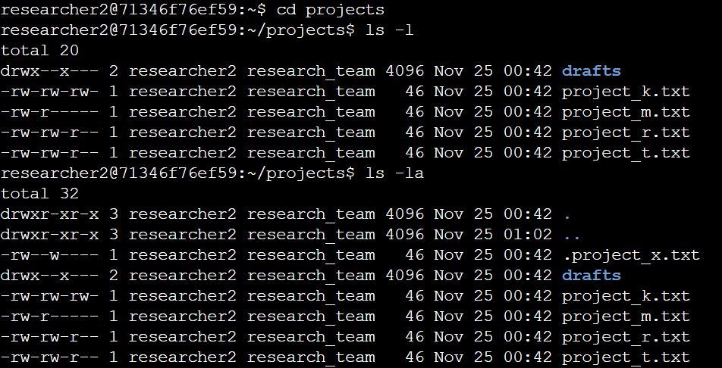
The output shows one hidden file (.project_x.txt), a drafts directory, and four project files. Each item includes a 10-character permissions string representing access levels for the user, group, and others.

Describe the permissions string
The 10-character permission string tells you the file type and the read, write, or execute permissions for the user, group, and others. For example, the permission string -rw-rw-r-- shows a regular file where the user and group have read and write permissions, while others only have read access.

Change file permissions
The organization decided that other users should not have write access. I identified project_k.txt as needing a permissions update and used the following command:
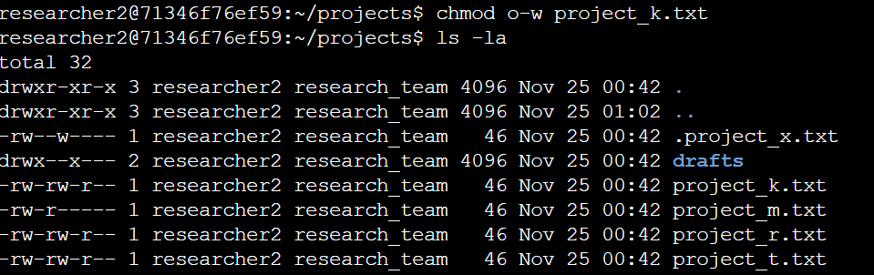
The first two lines of the screenshot display the commands I entered, and the rest of the lines are the output of the second command. The chmod command changes the permissions on files and directories. The first argument indicates what permissions should be changed, and the second argument specifies the file or directory. In this example, I removed write permissions from other for the project_k.txt file. After this, I used ls -la to review the updates I made.

Change file permissions on a hidden file
The research team archived .project_x.txt, so it should no longer have write permissions for anyone, but user and group should still have read access. I updated permissions with:
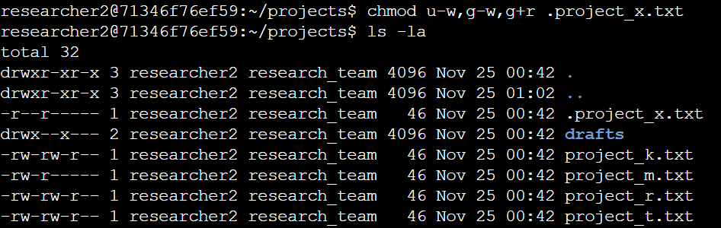
The updated ls -la output confirmed that project_x.txt was now read-only for user and group.

Change directory permissions
Only researcher2 should access the drafts directory. Since execute permission is required to enter a directory, I removed execute permission from the group using:
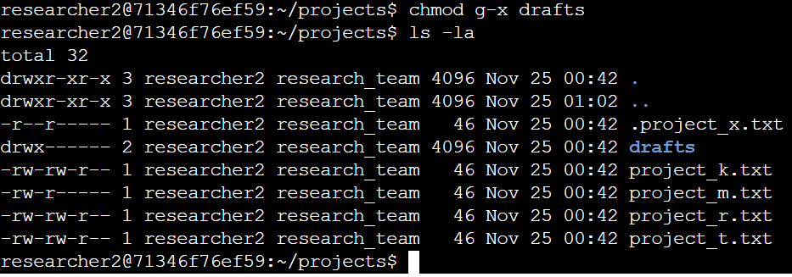

The updated permissions confirmed that only researcher2 retained execute permission.

Summary
To secure the projects directory, I reviewed file permissions using ls -la and then adjusted them with chmod. I removed unnecessary write and execute permissions and ensured hidden files and directories were properly protected. These changes helped maintain control over who can access or modify sensitive project files.

